|  |  |
| --- | --- |
| **Ex. No. 02** | **CONSOLE APPLICATION USING**  **CLASS & OBJECT** |
| **07.08.2023** |

**Aim**

To develop C# console application using classes, objects, constructors, getter and setter.

**Description**

**Class:** Blue print of an object

Contains:

* Fields: variables to store data
* Methods: Functions to perform specific tasks.

Syntax: class <class_name>

**Object:** Instance of a class

Syntax: <class_name> <variable> = new <class_name>();

Using dot operator with the object reference variable fields and methods of the class can be accessed

**Constructor:** looks like a method has same name as that of the class and it will be called automatically while creating an object to the class.

*3 types*: Default Constructor, Parameter less Constructor & Parameterized Constructor

**Getter:** Gives access to private fields, returns the value.

**Setter:** Allows to change the private fields, validation before the value is set

**Source Code**

using System;

namespace Ex2{

public class Movie{

private string name, theaterName;

private int noOfAvailableTickets, cost;

public Movie(string name, string theaterName, int no, int cost){

this.name = name;

this.theaterName = theaterName;

this.noOfAvailableTickets = no;

this.cost = cost;

}

public int tickets{

get { return this.noOfAvailableTickets; }

set { this.noOfAvailableTickets = value; }

}

public int Cost{

get { return this.cost; }

set { this.cost = value; }

}

public void display(){

Console.WriteLine("Name: " + this.name);

Console.WriteLine("Theater Name: " + this.theaterName);

Console.WriteLine("Available Tickets: " + this.noOfAvailableTickets);

Console.WriteLine("Cost: " + this.cost);

}

}

class MovieBooking{

static void Main(string[] args){

string name, tname;

int nos, price;

Console.WriteLine("Enter Movie Details");

Console.Write("Name: ");

name=Console.ReadLine();

Console.Write("Theater Name: ");

tname = Console.ReadLine();

Console.Write("#. Tickets: ");

nos = Convert.ToInt16(Console.ReadLine());

Console.Write("Price: ");

price = Convert.ToInt16(Console.ReadLine());

Movie movie1 = new Movie(name,tname,nos,price);

while (true){

Console.Write("\n1. Display \n2. Buy Tickets \n0. Exit \nEnter Your Choice: ");

int ch=Convert.ToInt16(Console.ReadLine());

if (ch == 1){

Console.WriteLine();

movie1.display();

}

else if (ch == 2){

Console.Write("Enter #. Tickets: ");

int no_t=Convert.ToInt16(Console.ReadLine());

if (no_t <= movie1.tickets){

int tot_cost = no_t * movie1.Cost;

Console.WriteLine("Total Cost: "+tot_cost);

movie1.tickets = movie1.tickets-no_t;

}

else { Console.WriteLine("Enter Vaild #. Tickets"); }

}

else if (ch == 0){

Console.WriteLine("\nThanks for Visiting");

break;

}

else{

Console.WriteLine("Enter a vaild Input");

}

}

Console.ReadKey();

}

}

}

**Output**

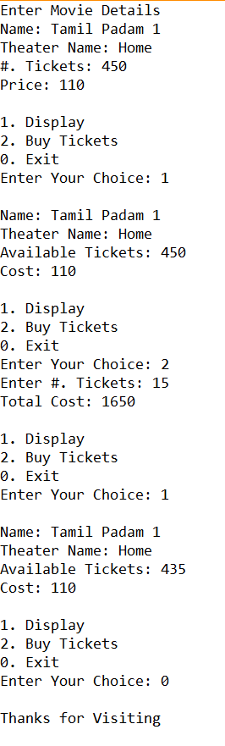

**Result**

The C# console application using class, object, constructor, getter and setter has been executed successfully and the desired output is displayed on the screen.